**1: Introduction to Kubernetes Declarative Approach**

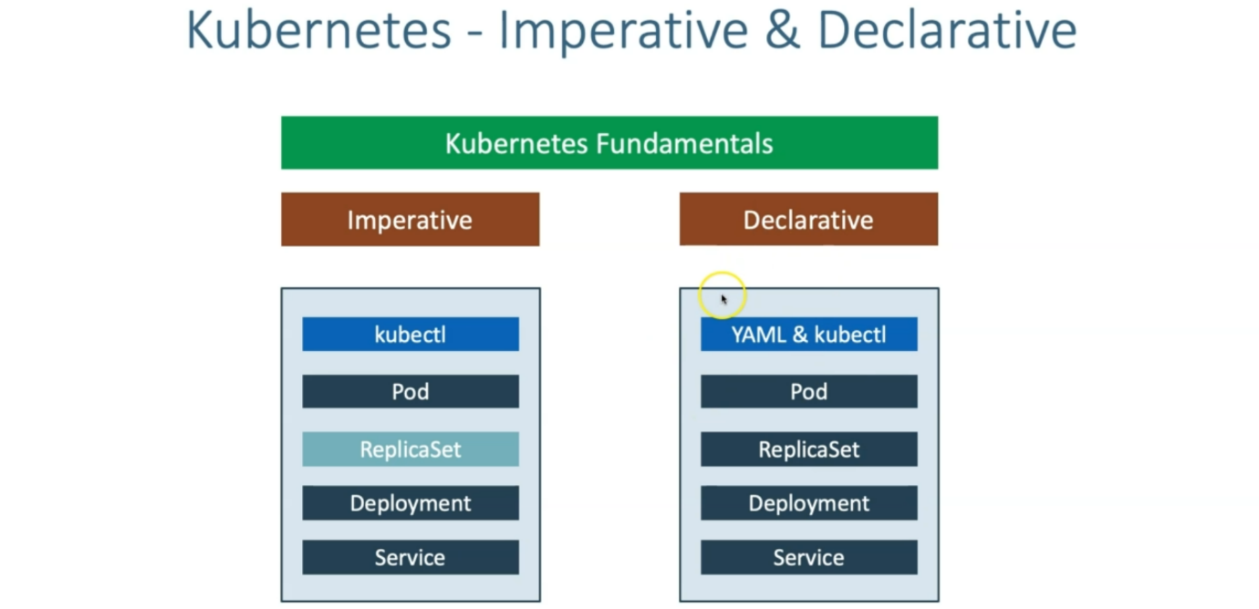

--- **note** – we are going to create pod, Replicaset, deployment, service in declarative way.